FAMU - FSU COLLEGE OF ENGINEERING
Senior Design Team 310
Professor: Dr. Hooker & Dr. McConomy

Project Charter

Authors:
Denis Dineen
Jacob Hutto
Hunter Kramer
Doran McFalls
Nicolas Palmeiro
Date:
January 10th, 2020


Mission Statement
Our team is committed to the development of an alternative solution for increased line worker safety. All team members will look to maintain a positive work environment which promotes professionalism, integrity, respect, and trust. Each member will contribute full effort to ensure a project which positively reflects the FAMU-FSU College of Engineering and all associated parties.

Roles
Each team member is delegated a specific role based on their experience and skill sets and is responsible for all here-within:

Team members:

Project Manager: Denis Dineen
Manages the team as a whole; develops a plan and timeline for the project, delegates tasks among group member according to their skill sets; finalizes all documents and provides input on other positions where needed. The team leader is responsible for promoting synergy and increased teamwork. If a problem arises, the team leader will act in the best interest of the project.
He keeps the communication flowing, both between team members and Sponsor. The team leader takes the lead in organizing, planning, and setting up of meetings. In addition, he is responsible for ensuring proper documentation for the progress of the project including meeting minutes. Finally, he facilitates presentations by individual team members and is responsible for overall project plans and progress.

Mechanical Design Engineer: Hunter Kramer
Takes charge of the mechanical design aspects of the project. Keeps line of communication with the project manager. He is responsible for knowing details of the design, and presenting the options for each aspect to the team for the decision process. Keeps all design documentation for record and is responsible for gathering all reports.

Power Engineer: Nicolas Palmeiro
Responsible for power consumption and needs calculations for the robot. Also will conduct research on most efficient and reliable sources to power the device. Additional role will be as team “Webmaster” who will create and maintain team’s website.

Mechatronic Design Engineer: Doran McFalls
Responsible for the mechanical design, material selection, and implementation of hardware. He creates the CAD models for the project and is responsible for the rapid prototyping of both mechanical and electrical design ideas. He maintains contact with the project manager, and submits documentation, designs, and purchase orders for approval.

Electrical Design Engineer: Jacob Hutto
Responsible for integrating hardware and software components of the design as well as submitting all documentation to the lead EE for approval.

All Team Members:
- Must maintain a positive attitude despite inevitable conflict
- Exhibit flexibility in planning and execution of tasks
- Support team members in their respective roles when needed
- Take ownership of individual work
- Communicates effectively and professionally with other members, sponsor, and advisor

Communication
The main form of communication will be over the phone, text-messaging, and GroupMe among the group, preferably GroupMe as well as through regular meetings of the whole team. Email will be a secondary form of communication for issues not being time-sensitive. For the passing of information, i.e. files and presentations, Microsoft OneDrive will be the main form of file transfer and proliferation.
Each group member will use their school email for the purposes of communication and file transference. Members must check their emails regularly for important information and updates from the group. Although members will be initially informed via GroupMe, meeting dates and pertinent information from the sponsor will additionally be sent over email so it is very important that each group member checks their email frequently. All responses should occur within 24 hours of original message.

Attendance Policy
If a meeting must be canceled, an email and GroupMe message must be sent to the group at least 24 hours in advance. Any team member that cannot attend a meeting must give advance notice of 24 hours informing the group of his absence. Reason for absence will be appreciated but not required if personal. Repeated absences (more than 2) without proper notification of excuse will be punishable by possible charitable donation to the team via pizza if voted for by the other members of the group. Continued absences by the same team member will enact the conflict resolution process outlined below.

Team Dynamics
The students will work as a team while allowing one another to feel free to make any suggestions or constructive criticisms without fear of being ridiculed and/or embarrassed. If any member on this team finds a task to be too difficult it is expected that the member should ask for help from the other teammates. If any member of the team feels they are not being respected or taken seriously, that member must bring it to the attention of the team in order for the issue to be resolved. We shall NOT let emotions dictate our actions. Everything done is for the benefit of the project and together everyone achieves more.

Ethics
Team members are required to be familiar with the NSPE Engineering Code of ethics as they are responsible for their obligations to the public, the client, the employer, and the profession. There will be stringent following of the NSPE Engineering Code of Ethics.

Dress Code
Team meetings will be held in casual attire. Weekly sponsor calls will be held in casual attire starting 9/27/2019 . Business casual – including suit jacket and button down shirt – will be worn for group presentations and meetings with sponsor (FPL) representatives. Professional attire will be incorporated into special occasions at the discretion of team members.

Weekly and Biweekly Tasks
Team members will participate in all meetings with the sponsor and instructor. Meetings with our advisor will be scheduled on an “as needed” basis. During said times ideas, project progress, budget, conflicts, timelines and due dates will be discussed. In addition, tasks will be delegated to team members during these meetings.

Decision Making
It is conducted by consensus and majority of the team members. Should ethical/moral reasons be cited for dissenting reason, then the ethics/morals shall be evaluated as a group and the majority will decide on the plan of action. Individuals with conflicts of interest should not participate in decision-making processes but do not need to announce said conflict. It is up to each individual to act ethically and for the interests of the group and the goals of the project. Achieving the goal of the project will be the top priority for each group member. Below are the steps to be followed for each decision-making process:
- Problem Definition – Define the problem and understand it. Discuss among the group.
- Tentative Solutions – Brainstorms possible solutions. Discuss among group most plausible.
- Data/History Gathering and Analyses – Gather necessary data required for implementing Tentative Solution. Re-evaluate Tentative Solution for plausibility and effectiveness.
- Design – Design the Tentative Solution product and construct it. Re-evaluate for plausibility and effectiveness.
- Test and Simulation/Observation – Test design for Tentative Solution and gather data. Re-evaluate for plausibility and effectiveness.
- Final Evaluation – Evaluate the testing phase and determine its level of success. Decide if design can be improved and if time/budget allows for it.

Conflict Resolution
In the event of discord amongst team members the following steps shall be respectfully employed:
- Communication of points of interest from both parties which may include demonstration of active listening by both parties through paraphrasing or other tool acknowledging clear understanding.
- Administration of a vote, if needed, favoring majority rule.
- Team Leader intervention.
- Group meeting with advisor to discuss conflict resolution.
- Instructor will facilitate the resolution of conflicts.
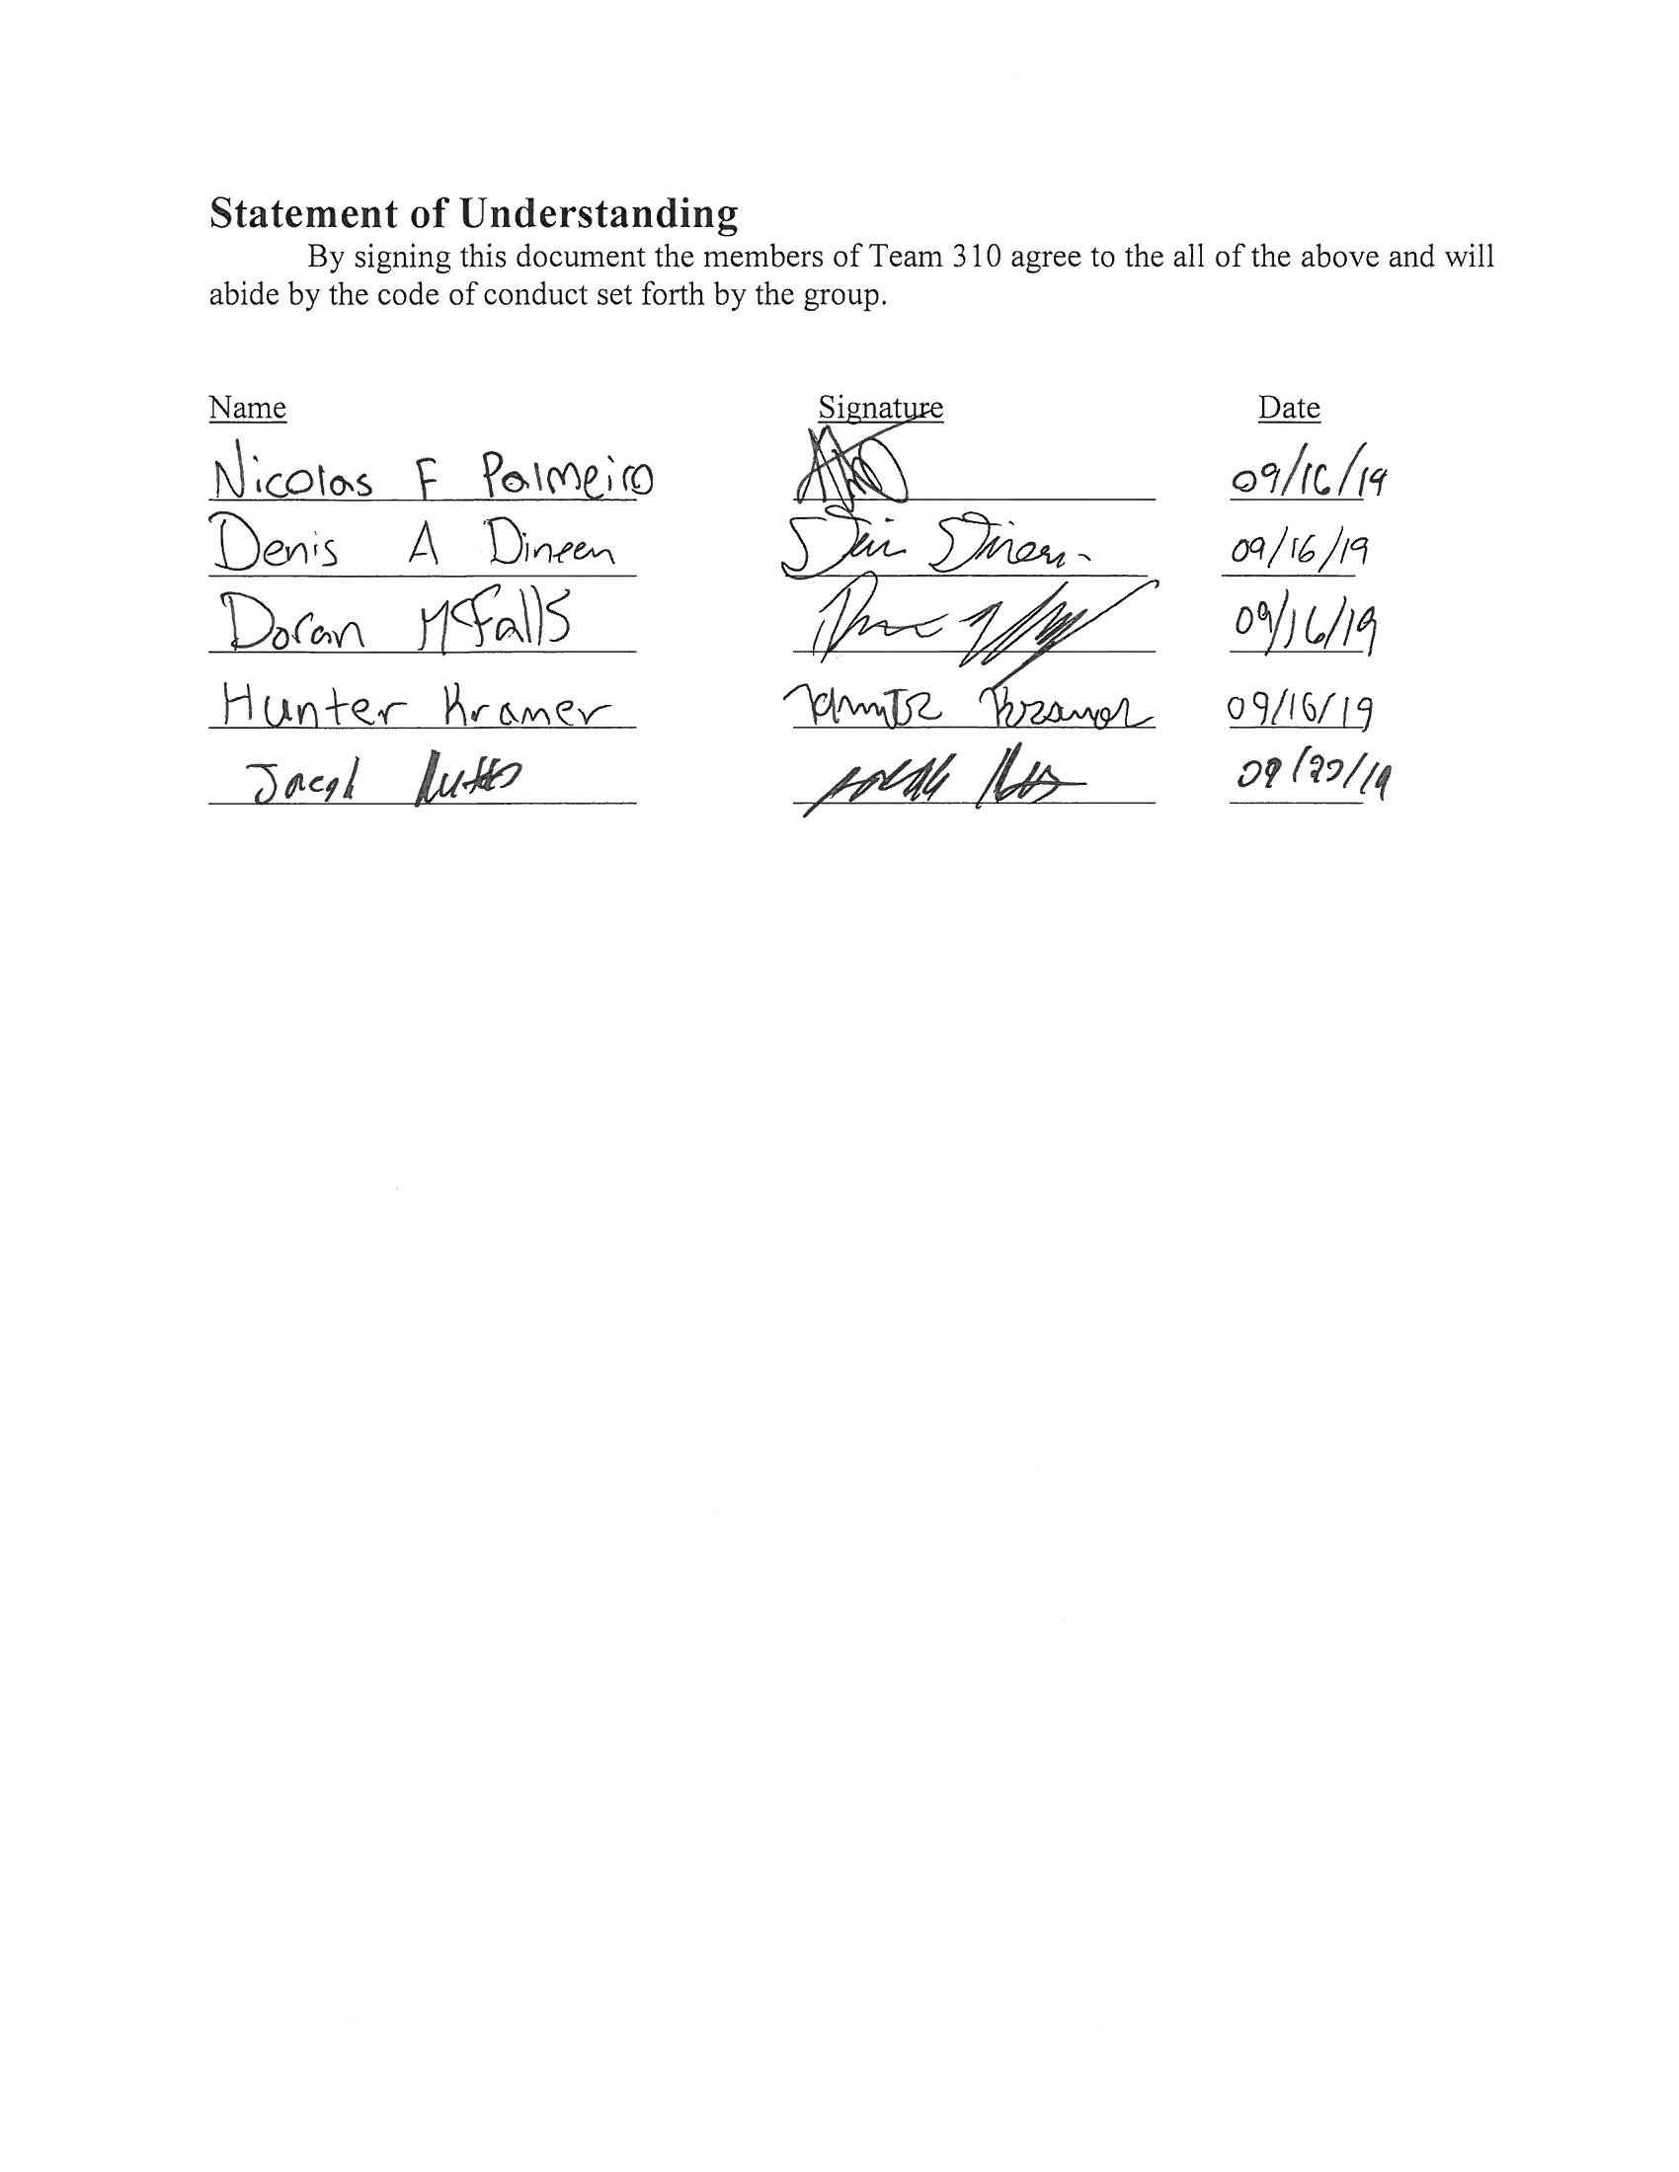

Project Scope

The objective of this project is to develop a telerobotic lineworker for Florida Power & Light utility company. The device should be able to perform routine actions - such as installation and repair - on power lines while being controlled from a close distance by a lineworker team. There are critical results we hope to accomplish through the design and implementation of our project. Some of these key goals are as follows:

- Improve lineworker safety while performing field work
- Increase overall efficiency of common line work (installation, maintenance, etc.)
- Incorporate user friendly controls based off proper training procedures

There are multiple markets similar to Florida Power & Light that could utilize this type of technology in their daily operations. Throughout many regions of the country educational and trade institutions are looking to train the next generation of lineworkers. The opportunity to use state of the art technology, including possible virtual reality training modules, would serve as a vital resource in the professional development of these students. Applying technology to perform routine actions in potentially hazardous environments extends beyond utility companies. Municipalities could incorporate this technology into fire and emergency medical operations to analyze a situation before human workers become involved. The same plan might relate to construction contractors – especially those who focus on high rise or industrial projects. Lastly, the recent damage within the Caribbean and along the southeastern portion of the United States shows our scope could even be brought to a national level. Emergency response organizations could make use of this technology to assist communities with property repair and damage assessments following natural disasters.
In order to prevent common pitfalls of scope development, our team has generated a list of assumptions that will control the parameters in which we work:

- Lineman will be present when operating the device.
- Operator will have completed proper training requirements prior to use.
- Line wires will be energized when device is in operation.
- Truck buckets will be uniform in size.
- Truck buckets will be isolated from the ground/other wiring.
- Standard repair equipment will also be located within truck bucket.
- Device will be used under standard line repair weather conditions.

Finally, our team felt it is important to recognize the groups and individuals who make this project possible. Our stakeholders contribute a significant amount of interest, investment, and control to the Senior Design program. Among our most important stakeholders are the following:

- Sponsor - Florida Power & Light
- Sponsor Contact – Genese Augustine
- Academic Instructor(s) - Dr. Jerris Hooker and Dr. Shayne McConomy
- Academic Advisor - Dr. Rodney Roberts
- Home Institution - FAMU-FSU College of Engineering
- Supervising Parties - local and state utility providers

We have included local and state utility providers as stakeholders due to their ability to pass regulations on the technology our team may be able to utilize.
One of the top priorities of Team 310 is to “maintain a positive work environment which promotes professionalism, integrity, respect, and trust”. We believe following this mindset will allow us to develop the best possible alternative solution for increased lineworker safety in a way which positively impacts all involved.

